Casual or Relaxed Pronunciation Diction

🗣️ What is Casual / Relaxed Pronunciation
# Source: Chatgpt (GPT-4-turbo) at [7/30/2025]
Casual or Relaxed Pronunciation refers to the informal and effortless way people often speak in everyday conversation, where syllables are reduced, sounds are merged or dropped, and speech is faster. This type of diction is natural, spontaneous, and often shaped by comfort and speed, not strict grammar or enunciation.

✅ Key Features:
# Source: Chatgpt (GPT-4-turbo) at [7/30/2025]
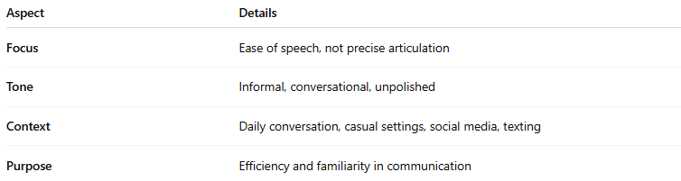
Aspect | Details
Focus | Ease of speech, not precise articulation
Tone | Informal, conversational, unpolished
Context | Daily conversation, casual settings, social media, texting
Purpose | Efficiency and familiarity in communication

🧠 Common Traits of Casual Pronunciation:
# Source: Chatgpt (GPT-4-turbo) at [7/30/2025]
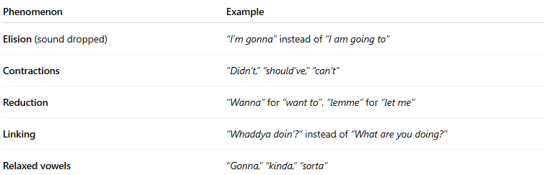
Phenomenon | Example
Elision (sound dropped) | “I’m gonna” instead of “I am going to”
Contractions | “Didn’t,” “should’ve,” “can’t”
Reduction | “Wanna” for “want to”, “lemme” for “let me”
Linking | “Whaddya doin’?” instead of “What are you doing?”
Relaxed vowels | “Gonna,” “kinda,” “sorta”

💬 Examples in Speech:
# Source: Chatgpt (GPT-4-turbo) at [7/30/2025]
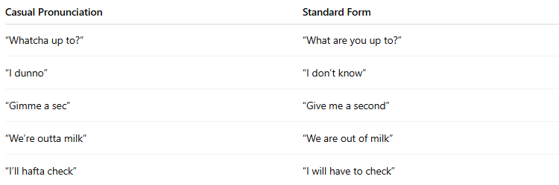
Casual Pronunciation | Standard Form
“Whatcha up to?” | “What are you up to?”
“I dunno” | “I don’t know”
“Gimme a sec” | “Give me a second”
“We’re outta milk” | “We are out of milk”
“I’ll hafta check” | “I will have to check”

🆚 Casual vs Clear/Precise Pronunciation:
# Source: Chatgpt (GPT-4-turbo) at [7/30/2025]
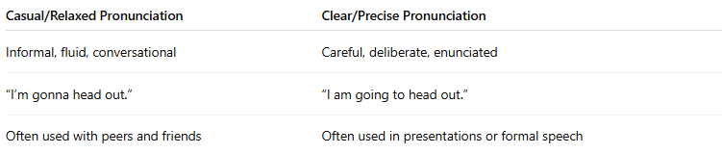
Casual/Relaxed Pronunciation | Clear/Precise Pronunciation
Informal, fluid, conversational | Careful, deliberate, enunciated
“I’m gonna head out.” | “I am going to head out.”
Often used with peers and friends | Often used in presentations or formal speech

🧭 Where It Appears:
# Source: Chatgpt (GPT-4-turbo) at [7/30/2025]
- Everyday conversation
- Television dialogue
- Informal interviews
- Podcasts
- Casual writing (texting, social media)

⚠️ Note:
# Source: Chatgpt (GPT-4-turbo) at [7/30/2025]
Casual diction is not incorrect—it’s context-appropriate. However, it’s best avoided in formal, academic, or professional situations where clarity and correctness are expected.

